Enterprise Transformation:

Agile Solutions Requires Developing for ‘Choice’

The Defense Finance and Accounting Service (DFAS) is in the frontline of systems integration, trying to cope with many legacy systems and thousands of interfaces. One of the primary missions of the agency is to unify financial support functions of an agency of the United States Department of Defense (DoD). Much of this effort has been on eliminating duplication/redundancy of systems through reuse and conformation to standards. Business reengineering has been focused on maximizing our Warfighter/business operations ratio. With a majority of business operations being touched by both finance and the development of an Enterprise architecture, DFAS work is, by extension, automatically pluralist involving other supporting business operations. In 2002, the Business Management Modernization Program (BMMP) began and its efforts will transform the DoD Enterprise of which DFAS is a major part. It is recognized that the transformation will require a thoroughly defined strategy, but to also transform the organization and its practices to be more agile and particularly able to respond rapidly to changes and requests to fulfill unforeseen new events and drivers. It is obvious that such a strategy is useless without changing the enterprise to be more adaptive.
WARFIGHTER
BU$INE$$ OPERATION$

When asked what single event was most helpful in developing the theory of relativity, Albert Einstein is reported to have answered, “Figuring out how to think about the problem.”
This paper starts with the applicability of these efforts sharing lessons-learned that are applicable to many organizations that are transforming themselves to be agile. Then wider needs are covered including: how to be more customer responsive, being proactive rather than reactive, and addressing new business requirements with declining budgets. The same set of principles given here applies for all information systems that offer diffused and distributed content that is difficult to manage, coordinate, and evolve. In this regard we will also be discussing the Business-Centric Methodology (BCM) effort underway at OASIS that seeks to address the challenges of agility and interoperability through the adoption of a business first philosophy. However, before we start this analysis we need to examine the process of change itself.

Our solution might be our number one challenge
As we attempt to transform the Enterprise, we need to review the rationale of previous decisions to better understand how to move forward. This task is a Herculean one that requires rewiring our established views and along with it the culture of the Enterprise. “You can’t see the good ideas behind you by looking twice as hard at what’s in front of you” is an appropriate quote by famous innovator Andrew Mercer, and validates a diligent review of what we have in order to be able to move forward.

Certainly our introspection will reveal that success breed’s success; that each small, successful step reinforces the next step. As we reframe our perspective, it is very important to understand these successes and be appropriately critical of those that have been missed. This appreciation of lessons learned provides information quickly, effectively and reliably to the Enterprise. At first the approach seems straightforward: (1) identify the symptoms of the problem, (2) extract root causes, (3) prioritize the causes, (4) identify solutions implemented or previously considered, (5) make an assessment, and (6) validate the assessment through proof of principles projects, testing, surveys, etc. But we need to add a critical missing step to our process – we need to be able to see the overall structure of the problem – the dominant idea. Once we recognize the dominant ideas that frame our perception of a problem, we can apply lateral thinking exercises, such as the (7) laws of organization: proximity, closure, similarity and simplicity. If we find that the current solution is not applicable to our problem, then our challenge will be not only the implementation of the new solution but also the challenge of changing the current mindset.

Collaborate not mandate

One area of introspection is with the Enterprise environment – understanding that to be successful organizations need to collaborate rather than mandate if alternatives exist. The danger in a large organization is that parallel worlds and approaches spontaneously exist and do not interact. Studies of our lessons learned reveal that instead of attempting to create homogeneous situations, it is best to recognize, and build mechanisms for working within, heterogeneous environments. These mechanisms not only include integration goals, but also the understanding that, in some cases, that the best we can hope for is to lower the bar for interoperability between the various stakeholders. Accepting a heterogeneous environment requires a deliberate resolve, having a functional view rather than a systems view of the Enterprise – particularly when incorporating a Service-Oriented Architecture (SOA). An SOA differs from an application-based architecture in that it allows for a loosely coupled structure where standard mitigation through partnerships is preferred to issuing ‘Standard Data’ directives. The latter approach limits Enterprise agility when compared to a strategy that leverages best-of-breed components. This is true for the complete spectrum from architectures to validation look-up tables. As we cross organizational boundaries, we need to avoid conflict through mitigation mechanisms such as sharing concepts within ontologies. In short, developing a strategy for providing controlled ‘choice’ across boundaries and systems is the optimal approach.

Analogy
Our analogy for the problem at hand can best be compared to manufacturing prior to 1789 when guns for our military were handmade; no two were alike. The guns were extremely costly to manufacture and maintain until Eli Whitney, inventor of the cotton gin, contracted with the United States government to make 10,000 muskets. Whitney designed a new gun and the machinery to make it. His machine manufactured parts exactly alike. Each part would fit any of the guns he made. Whitney also created division of labor, in which each person specialized in making one part of the gun. The final step was merely to assemble the interchangeable parts.

In 1913, Henry Ford combined Whitney’s concept with a continuous moving assembly line and by 1918, half of all cars in America were Model Ts. The vehicle initiated a new era in personal transportation. It was easy to operate and maintain. In a modern car factory today, pattern configuration knowledge embodied in the assembly line that allows for automobile lines to have thousands of variants in the final product. Today the modern automobile is developed for consumer ‘choice’.

As applied to information technology
Extending our analogy, into the information technology age, we have demonstrated success in applying Whitney and Ford’s principles. We have pressed the concepts of interchangeable parts and mass production with our development efforts where component-based development is now the norm. Web services will continue to take these ideas forward, providing the vehicle for efficient business line interoperability. But which Web service to invoke, when to invoke it, and what are the parameters?
Quite simply, if collaboration partners can’t agree at the Conceptual layer then business can’t happen. If partners go on to further agree at the Business or Extension layers then we achieve reuse. Today, much of the effort is tactical, and takes place at the Implementation layer where the opportunity is least and redundancy is at its maximum.

To answer these questions, we need to continue with our analogy, viewing our organizations as information factories. Standardization is not the final answer to providing customer satisfaction or managing diverse information sources. Due to the nature of information and the nature of our interoperability challenge, we need to extend Eli Whitney’s standard approach and elaborate on Ford’s assembly line. We need to extend mass production concept to include mass customization of our information value chains. To do this, it is imperative that information within our value chains is syntactically and semantically accessible.


Syntax problems involve not just format and structure. We must understand the context and implied meaning of information that can be critical in making accurate and timely decisions. Semantic changes are deltas in information practice (i.e., usage by additional applications or modification in usage). Change drivers are frequently due to shifting customer demands, new operational efficiencies, technology adoption, and consolidation. Because of this, standards are a mixed bag. When vendors seek to gain competitive advantage and overcome market inertia through development of complex standards, productivity can be impeded. In other cases, simple and intuitive standards facilitate rapid deployment. Access to understandable semantics relates directly to timeliness and integrity of the information. Semantic exchange is the most difficult integration problem for organizations, but clearly this issue needs to be addressed if our organizations are to become more agile and better able to adapt to change.

Opportunity
The Business-Centric Methodology (BCM) effort underway at OASIS addresses the challenges of agility and interoperability through the adoption of a business first philosophy. The BCM facilitates the capture of decision rationale and involves the business experts to scope, define, relate and manage the business semantics concisely. Business users and customers can communicate concerns and aspects of the business more easily and accurately than developers can. The BCM’s declarative approach allows business users to take back the “steering wheel” of development and integration, much like the car factory evolved from machinist –built Model Ts to the modern factory’s process configured by the customer’s job order. The BCM Contract (job order) approach handles potentially thousands of relevant Choice Points in an organization through patterns defined via predefined BCM Templates, rather than being lost in tactical software programs.
The BCM provides a clean separation of concerns in four layers: Conceptual, Business, Extension, and Implementation. Each layer is defined by its primary aspects, which are natural and intuitive means for providing a solution for interoperability. This separation allows for maximum reusability in terms of both components and aspects. The prime Conceptual layer aspects are business goals and authoritative sources; significant Business layer aspects are business drivers and process constraints from an Enterprise preferred viewpoint. The major aspects of the Extension layer are legacy systems, frameworks and Communities of Interest (CoI), and the Implementation layer chief aspects are those driven by specific collaboration partner constraints.

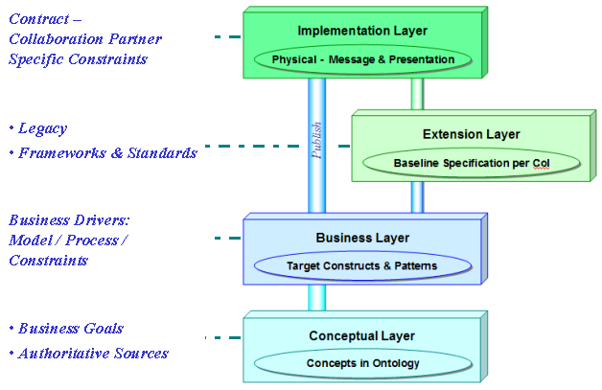
Managing choices
The layers of the BCM represent major points of interface where choices must be made. But there are many more physical interfaces within an organization, and how these separations work impacts its business functions. Within large organizations, decisions involve thousands of variants of business choices, business rules, business patterns, and data permutations. Organizations need to manage these Choice Points in a proactive manner, capturing both options and their rationale. The intentions can then be stored and reused for efficiency and refinement. The explicit identification and management of these Choice Points significantly aids to comprehensibility, alignment, while promoting tracing and accountability. In large organizations, the vectors at each decision point, and their interrelated linkage can become quite complex. An agile organization extracts these relationships as business patterns and separates the Choice Point vectors out as parameters for each context. The declarative approach of the BCM improves comprehensibility and reduces the probability of errors, as processes are orchestrated based on user’s choice. Returning to our Web services question about which Web service gets invoked depends on the business pattern and choices made. The Choice Point calls the service and supplies it with the proper parameters. Unfortunately these Choice Points aren’t typically managed and many times completely ignored in enterprise planning or design. One can only imagine the convoluted deployment of Web services within these organizations; always behind the eight ball as they attempt to control their business rules so that change can occur. On the other hand, an agile organization understands clearly that to avoid change paralysis, managing these Choice Points provides a critical baseline and is used for future impact investigation and gap analysis. Today, organizations must develop for choice.

Developing for choice
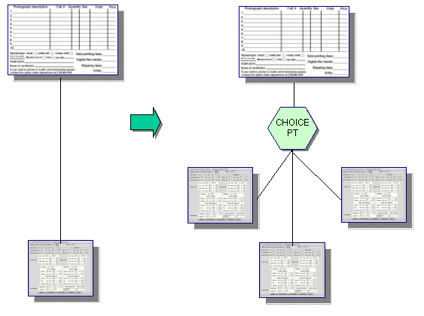
The BCM utilizes a ‘contract’ to formalize the combination of workflow, processes, schema, maps, rules, et al into BCM artifacts. The underlying principle is that each BCM layer is to solve its problem, and only its problem, based on a focused set of constraints. Information that is not known during design or runtime is deferred up a layer – thereby providing “help from above”. In between each layer are Choice Points, providing the information or invoking the appropriate BCM Templates based on selected patterns and formalized by the contract.

The specific combination of BCM products and their interrelationships determines the BCM Templates needed to generate Choice Points and variables across an identified pattern. Contract instantiation creates objects at runtime that interact as described by the contract; e.g. Web services. Through the use of contracts and event management, dissemination of change from the requirements through to implementation is greatly simplified.

Choice Points can be seen as providing three enablers for agile information exchanges:

- Context criteria, where the scope of the context extends beyond the local decision point, and can also require persistence of decisions

- Determining context by refining criteria dynamically, and that may include undetermined start points

- Where the context requires a thread manager to establish and track the state of a process.

Unfortunately, development tools in this area are relatively immature and will require architecture and design deliverables that sit outside of today’s CASE tools. It is anticipated that these tools will begin to incorporate these Choice Point decision mechanisms in future releases, but until then organizations will need to improvise and augment their current tools and architectures. The OASIS BCM TC effort underway has been tasked to provide an industry specification on these linkages and specifically the detailed definition of a Choice Point service.

Within the BCM there is the need to identify various key interactions and primitive entities that describe an interoperable business scenario. These include partner definitions, collaborations and roles, process definitions, information transactions and semantic details. Using this set of factors and participants we can then state the following:

- Qualifying context is key to ensuring correct relationships between partners in business collaborations;
- Knowing context is needed to ensure accurate information capture, packaging and delivery;
- Lack of context control (of the processing and transactions) is the single most prominent reason why legacy e-Business systems are complex to implement and support;
- Providing and managing context is needed to drive dynamic process configuring and control;
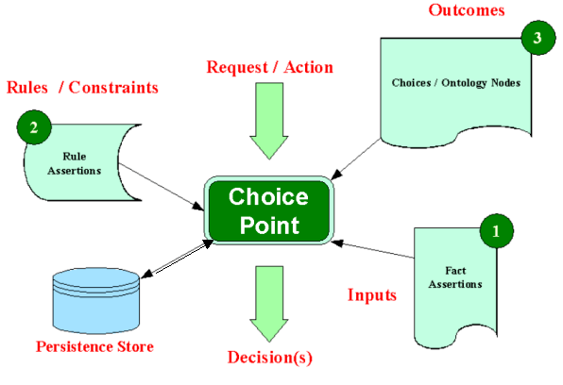
- Defining ontology both of the Choice Points themselves and including Choice Points within ontologies.

Context can be viewed as a series of cascading Choice Points that have inputs through the assertion of facts, the operation of rules and constraints, which determine the outcomes from available choices. These range from the very simple – “if then do” style - to event handlers, to state management, to complex decision agents that operate on sets of dynamic facts that include status information about concurrent operations.

Of course implementations must be able to choose how simple or complex their needs are and implement Choice Points accordingly. The rules selections may vary from simple binary choices through to complex decision support questions such as “buy or repair?” logistics. The BCM Choice Point approach is designed to scale from the simple to the complex in a linear and consistent way.

The context mechanism itself needs to be multifaceted in the types of decision choices that can be determined and controlled.

Three primitive Choice Points types for both design and runtime are required: (1) Nouns or data (BCM artifacts included), (2) Verbs or processes and workflows, and (3) Relationships, from data models linkage to Contracts themselves. The mechanism can be internal to a product (modeling, mapping, etc.) or as a Web service to the Enterprise as part of a comprehensive infrastructure. The service essentially returns the parameters based on state of all input vectors as defined by the relationships and business rules as declared by the business user.

Experience teaches us that today’s organizations are too complex to be modeled with lines and boxes. Current modeling techniques are adequate for showing sub-classing, path options, sets of codelists, or object-role variances; but they fall short in tracing the thread of user choices. This is where the BCM differs significantly from current methodologies as it directly embraces and provides support for choice.

For more information on the Enterprise Transformation- Agile Solutions Requires Developing for ‘Choice please contact Ms. Audrey Davis, Director for Information and Technology, Defense Finance and Accounting Service, DFAS CIO, Audrey.Davis@dfas.mil. For more information on Business-Centric Methodology visit: http://www.dfas.info

Multiple choice
Today’s organizations must decide how they are going to process their information value chains.

Take this simple multiple choice test:

Does your organization want to:
A. ( ) architect du jour ‘to be’ designs
B. ( ) develop for choice

The answer is obvious- if the organization is to be successful in today’s environment. Just as in nature, the organization that has embedded agility and choice within its processes thrives. Agile organizations are assertive, always learning, and perpetually applying their lessons learned as they transform themselves for the uncertain future. The ability to respond and adapt to business forces outweighs the ability to predict today the problems and solutions of tomorrow. The BCM provides an approach for organizations to better manage their choices and governs the timing of those choices within a stable information architecture baseline.


OASIS - Organization for the Adoption of Structured Information Standards, http://www.oasis-open.org

